Pokhara University

Level: Bachelor | Semester – Spring | Year : 2007
Programme: BE |  | Full Marks: 100
Course: Electronic Circuits |  | Time : 3hrs.

Candidates are required to give their answers in their own words as far as practicable.
The figures in the margin indicate full marks.

Attempt all the questions.

 | - What are the different coupling methods used in multistage amplifier? Discuss the advantages and disadvantages of R-C coupled amplifier.  - For the amplifier circuit given below find:  i) r_{in} ii) r_{out} iii) A_{v} iv) A_{vs}  where the symbols have their usual meanings. (Given β = 100, r_{e} = 20Ω).  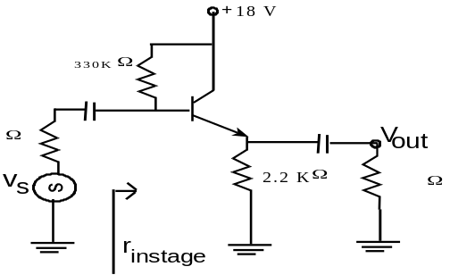  1 KΩ  10 KΩ | 3+4  8
 | - Define lower cut-off frequency, up per cut-off frequency and Bandwidth. The amplifier shown below has mid-band gain equal to – 150. Find the approximate valve of upper cut off frequency.  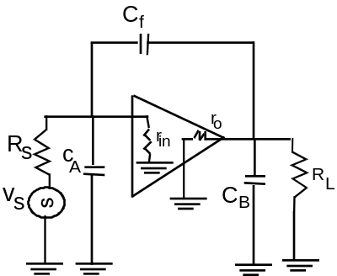  Assume: C_{A} = 50 pF, C_{B} = 60 pF, C_{f} = 20 pF,  R_{s} = 1000 Ω, r_{in} = 2000 Ω, r_{o} = 1000 Ω  R_{L} = 4.0 KΩ  - Explain how two complementary transistors in class B push-pull amplifier act simultaneously as complementary symmetry class B push pull amplifier. What is cross-over distortion? | 3+5  5+2
 | - Explain the effect of negative feedback in amplifier characteristics.  - State Barkhausen criterion for oscillation. Explain RC-phase shift oscillator and derive resonant frequency. | 7  2+6
 | - Draw the basic block diagram of an Op-Amp and briefly explain the operation of each block. Draw and explain Op-Amp as subtractor.  - What are the main characteristics and features of Op-Amp? Define the following terms: output offset voltage and virtual ground.  - Explain monostable multivibrator with circuit diagram. | 5  3+2  5
 | - Draw and explain the temperature compensated logarithmic amplifier circuit with mathematical derivation.  - Draw R-2R ladder network for DAC (Digital to Analog conversion) and verify it with suitable example. | 8  7
 | - Draw flash type (or parallel type) ADC and explain its operation with the help of truth table. Explain why its conversion speed is very fast.  - What do you mean by regulated and unregulated power supply? Draw transistor shunt regulator circuit and explain its operation. | 7+1  7
 | Write short notes on (Any Two):  - Darlington pair amplifier and its effective current gain  - Advantages of differential amplifier  - Schmitt trigger  - Crystal oscillator | 2×5

